**IE 471 Final Exam**

**Abdalaziz Hamadi**

**Winter, 2016**

**Movie:** Song of the Sea

**Project:** Escaping Granny’s House

**Project Manager:** Ben

**Question 1:**

I believe Ben was effective. According to Cambridge English Dictionary, effectiveness is defined as “the ability to be successful and produce the intended results” [1]. Ben can be considered an effective project manager because his actions conform to this definition. For example, Ben successfully completed the project objective as intended, where he escaped Granny’s house and reached the lighthouse within the planned time and budget.

Another reason why Ben is considered effective is the fact that he possesses the five core personal characteristics of effective project managers, which are presented in the Project Times website [2]. These characteristics are listed below:

* Being an extrovert
* Display personal courage
* Possess charisma
* Be an enabler with a can do attitude
* Have a strong sense of teamwork

The table below explains how Ben demonstrated these characteristics during the completion of the project.

|  |  |
| --- | --- |
| **Characteristic(s)** | **Example** |
| * Being an extrovert * Display personal courage | Ben had always been comfortable leading negotiations with the Denashee and Macha to convey the team’s demands. Also he made necessary decisions, such as ordering Saoirse to stop playing the seashell so that the evil fairies living in the forest are not attracted by the noise. Even though his decision made Saoirse unhappy, telling her to stop allowed the team to avoid trouble and get to the lighthouse safely and on time. |
| * Possess charisma * Be an enabler with a can do attitude | Saoirse and Cu were following Ben throughout the entire journey because they have faith in his leadership. He had the ability to train and mentor them whenever they faced difficulties. Due to Ben’s positive attitude, Cu and Saoirse established trust with Ben and knew that he was always looking for the best way to overcome the challenges they faced. |
| * Have a strong sense of teamwork | When Saorise was feeling tired from traveling through the forest, Ben kept motivating her to keep going. When she eventually passed out from exhaustion, he carried her on his back until they found shelter. This situation displays his ability to support, motivate, and cooperate with team members. |

**Question 2:**

I believe the project team was not effective. In an article by Massachusetts Institute of Technology, Judith Stein emphasizes that the Stages of Team Development are: forming, storming, norming, performing, and termination/ending [3]. Stein stresses “Behaviors during the Norming stage may include members making a conscious effort to resolve problems and achieve group harmony” [3].

This was not the case between Saoirse and Ben. When Saoirse and Ben had a disagreement on the bus about which route is better to reach the lighthouse (Ben wanted to take the bus because it is safer and Saoirse wanted to take the forest path because it is less boring), Saoirse decided to get off the bus without any effort to resolve the problem to reach a mutual solution. This has affected the quality of the performing stage as the team was forced to follow Saoirse through the forest, where they experienced difficulty completing their tasks due to harsh weather conditions and exhaustion.

Another reason why the team was not effective is because they lacked some major characteristics of an effective team. The authors of Management Study Guide website (known as MSG Experts) lists 20 characteristics of an effective team [4]. The table below lists the characteristics that the team has failed to achieve and some examples to support the claim.

|  |  |
| --- | --- |
| **Lacking Characteristic(s)** | **Example** |
| * Competent members | Saoirse and Cu lacked the knowledge and skill to get to the lighthouse by themselves. Hence, they needed Ben to constantly tell them what the next objective was. |
| * Each team member trusts the judgment of others * Dissenting opinions are never ignored | During the bus ride, Saoirse got off the bus because Ben didn’t trust her idea about taking the forest path and ignored her request. Similarly, Saoirse didn’t trust Ben’s judgment that a bus ride was the best method to get to the lighthouse. |
| * Risk Taking | Cu and Saoirse dived into the holy well because it was a short cut that leads to the lighthouse by swimming. However, Ben was hesitant and refused to dive because he didn’t want to risk the chance of drowning. |

**Question 3:**

From the first chapter in the class textbook, Figure 1 below displays the sociocultural dimensions of project management [5]. There are various areas of opportunities for the project team when considering these sociocultural dimensions.

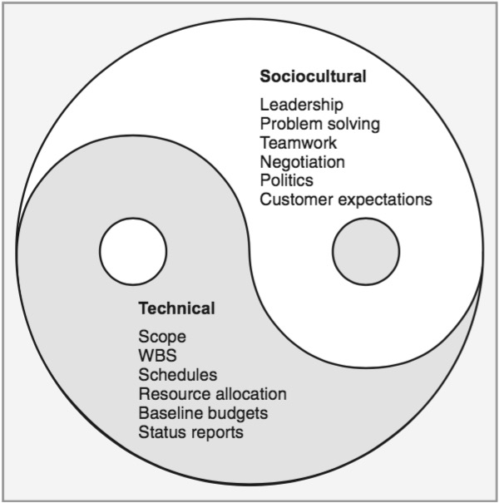

**Figure 1:** The Socio-Technical Dimensions of the Project Management Process

The table below includes which areas of opportunity are needed to improve the social system of the project team, the reasons why the areas of opportunity are selected, and specific recommendations for improvement.

|  |  |  |
| --- | --- | --- |
| **Area of Opportunity** | **Reason for Selection** | **Recommendations for Improvement** |
| 1. Problem solving | Ben and Saoirse were constantly having arguments throughout the journey without trying to reach a mutual agreement. Such unsolved conflicts have caused project progression delays. An example of this is when they got lost in the forest because Ben ignored Saoirse’s warnings and did not discuss with her the possible routes they could have taken. | I recommend having a daily 30-minute session where team members can express their feelings and concerns and try to solve any issue a team member might have. This prevents any conflict from getting bigger during the progress of the project. |
| 2. Teamwork | Macha almost turned Saoirse into stone when the evil fairies caught Saoirse as she was traveling by herself near Macha’s house on her way to the lighthouse. This could have been prevented if the whole team traveled together as one unit to support each other against the dangers along the road. Saoirse went by herself because she felt that the team did not need her to complete the project objective. | I recommend that Ben try to establish with his team the importance of collaboration among the team to achieve the project objective as well as creating a positive atmosphere to boost the team’s morale. To do that, I suggest assigning two people for each task (one is responsible for completing the task while the other is a “backup” person that offers assistance only if the other member is struggling with his/her task). This encourages cooperation between members so that they complete the project objective as smoothly as possible. |

**Question 4:**

Referring back to Figure 1 in Question 3, there is potential improvement for the team when considering the technical dimensions of project management. These technical dimensions might help Ben better plan, schedule, and control the project through improved management process. Below are the areas of opportunity that will benefit the team the most, the reason they are selected, and recommendations for improvement.

|  |  |  |
| --- | --- | --- |
| **Area of Opportunity** | **Reason for Selection** | **Recommendation for Improvement** |
| 1. Create project schedule | Ben figured out what tasks needed to be completed to finish the project. However, he did not account for the duration to spend on each task. This slowed down the progress of the project on several occasions. For instance, the team had to spend an entire day gathering food and resources around the Holy Well because they ran out of food/water after staying there for too long planning for the next step. | I recommend creating a Gantt Chart that includes: the name of the tasks, the duration, and people responsible for the tasks. Next, the Gantt Chart should be distributed to all team members. This allows the team to be aware of the upcoming tasks so that they can prepare the tools and resources needed before each task, since they know how long they will stay on each task. |
| 2. Develop status reports | Ben always assumed that his teammates are doing well, until something unexpectedly goes wrong. One factor contributed to Saoirse passing out in the woods from exhaustion is because she was not feeling well in the past two days of constant traveling. Ben was never aware of Saoirse’s condition because he was not being updated with her progress on a regular basis. | Based on the nature of the project, I suggest having each team member prepare a status report for Ben every three days. This keeps Ben updated with the progress made and allow early detection of any problem a member is having, giving plenty of time to resolve the issue. The frequent updates insure that the project is going as planned. |

**References**

[1] Effectiveness Meaning in the Cambridge English Dictionary. (n.d.). Retrieved March 13, 2016, from <http://dictionary.cambridge.org/dictionary/english/effectiveness>

[2] Hamilton, G., Byatt, G., & Hodgkinson, J. (2010, July 6). Anatomy of an Effective Project Manager. Retrieved March 13, 2016, from <http://www.projecttimes.com/articles/anatomy-of-an-effective-project-manager.html>

[3] Stein, J. (n.d.). Learning & Development. Retrieved March 13, 2016, from <http://hrweb.mit.edu/learning-development/learning-topics/teams/articles/stages-development>

[4] MSG Management Study Guide. (n.d.). Retrieved March 13, 2016, from <http://www.managementstudyguide.com/characteristics-good-team.htm>

[5] Larson, E., & Gray, C. (2014). Chapter 1: Modern Project Management. In *Project management: The managerial process* (6th ed.). New York: McGraw-Hill Irwin.

**Bibliography**

*Song of the sea* [Motion Picture]. (2014). Universal Pictures Home Entertainment.